Test Report and Exploration

The test result
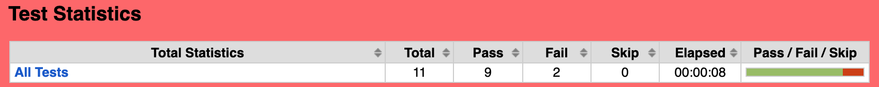

- All functional testing of registration system and login process are passed.
- System accept all input (space, numbers, alphabet and special characters) as entry.
- All fields are mandatory.
- Only when all condition are met, entry can be accepted by system.
- Two API tests are failed. Delete and Post API are not working with current system design.

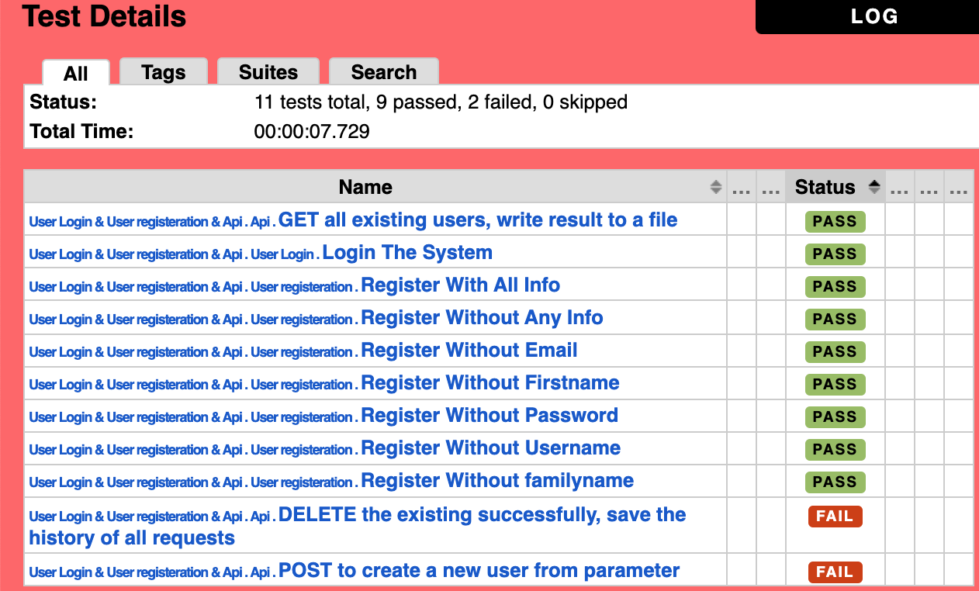

Exploration
As there is not any product specification delivered with software, all test criteria are made based on exploration. Tester first tried with frequent test criteria for such system, for example:
- mandatory fields
- boundaries of each fields (numbers of digits, different types of characters that accepted by system, space, special characters, etc)
- password regulation
- update/change after entry accepted by system
- delete one existing entry
- different roles of accessing the system
- log in success/failed condition
After manual testing, testers got the basic process and created happy flow test case, then added test cases that will cause failed of the entry (missing mandatory fields).

There are also other exploration done as trying different button on the page, tried to click all text and see if there is function behind.

API test was done with GET, PUT, POST, PATCH, DELETE and get only GET through. In order to keep API test package complete, there are also POST and DELETE test cases. Other API cases are not added due to the obvious fact that updating was not included in current functionality.

